**PRACTICUM REPORT**

**ALGORITHM AND DATA STRUCTURES**

**Quiz**



**Disusun Oleh :**

**ONIC AGUSTINO**

**L200234275**

**X**

**INFORMATICS ENGINEERING**

**FACULTY OF COMMUNICATION AND INFORMATICS**

**UNIVERSITAS MUHAMMADIYAH SURAKARTA**

**YEARS 2024/2025**

**1.11 Questions**

1.Question 1: Data Statistics in a List

Given the daily sales data of a store over 10 days in the form of a list:

sales = [105, 95, 130, 105, 160, 140, 115, 160, 115, 160]

Your tasks:

1. Calculate the average daily sales.

2. Determine the day with the highest and lowest sales.

3. Sort the sales data from lowest to highest.

4. Create a function that takes a specific value and returns how many times that value appears in the list.

5. Modify the list so that it only contains unique values (no duplicates).

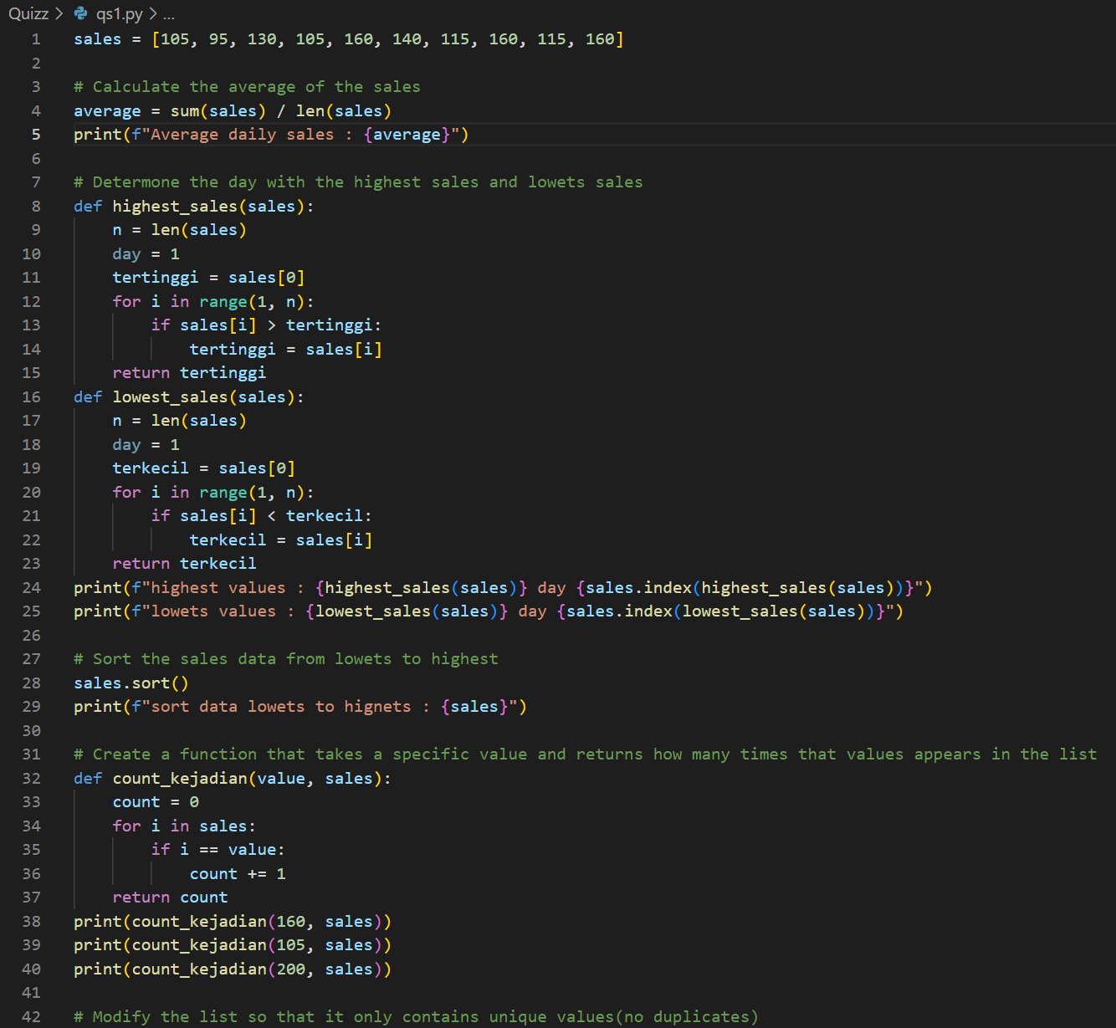

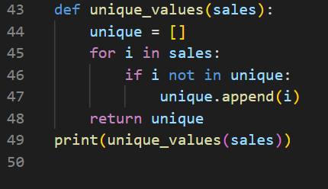

Picture 1.1 the code of qs1

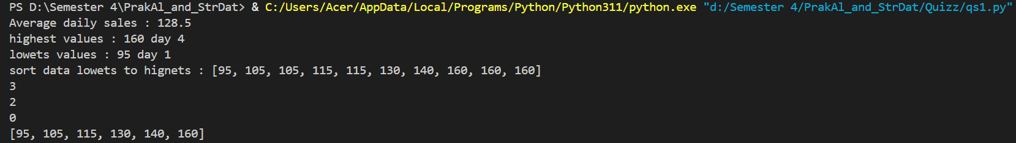

Picture 1.2 the output.

1. Question 4: String Data Processing

Given the following **sentence**:

sentence = "Programming in Python is fun and beneficial.”

Your tasks:

1. Count the number of words in the sentence.

2. Find and count the number of vowel letters (a, e, i, o, u) in the sentence.

3. Reverse the order of words in the sentence without using .split() and .reverse().

4. Replace every vowel letter with the character * and print the result.

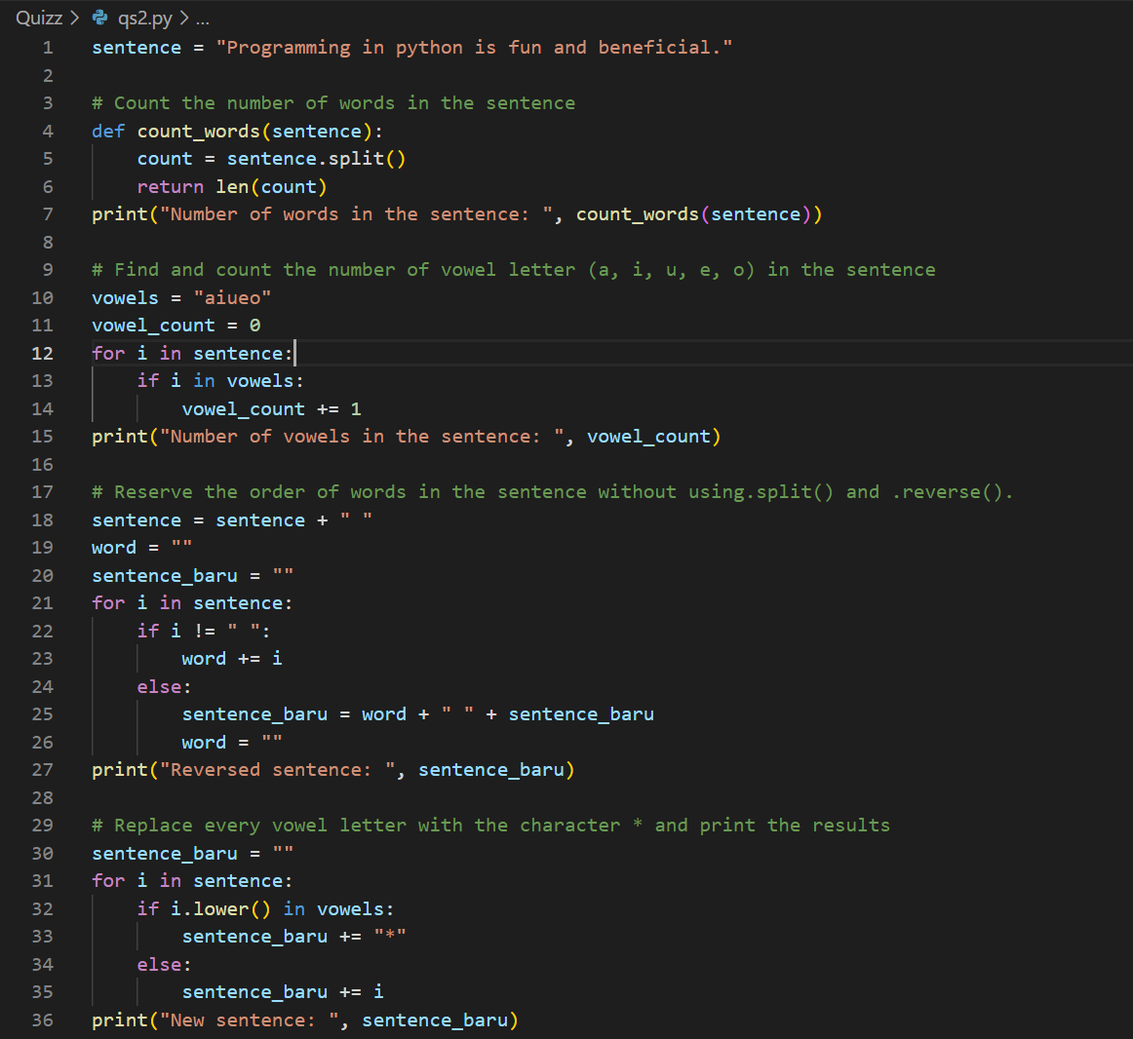

Picture 2.2 the code qs4



Picture 2.2 the output.